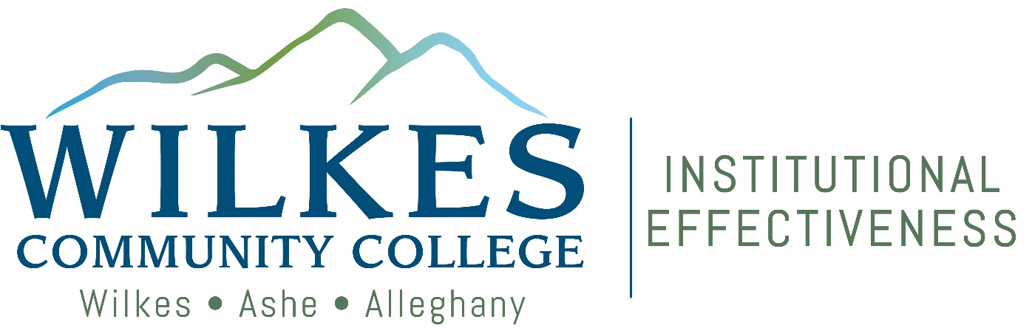

Compliance Assist
Planning Module
Strategic Planning Guide

Wilkes Community College – Compliance Assist Strategic Planning Guide

Beginning in the Spring of 2012 all WCC departments and functional units will be using Compliance Assist to input and track their departmental goals. Using this system will allow the college to track the progress of all goals college‐wide with a single report and show progress towards the colleges mission and its 7 strategic initiatives. To review the strategic initiatives and planning goals, click on the link to the Strategic Planning webpage:

This guide will help you to navigate the Compliance Assist planning system and also give suggestions in the development of departmental goals.

Goals are different from Student Learning Outcomes or Administrative Program Outcomes and are entered under the College Strategic Planning tab which is located next to the Assessment tab.

Goals should be program‐focused. For example, it’s appropriate for a program goal to be that all faculty attain a particular certification or credential, however an individual’s personal professional development or education is in most cases not an appropriate goal.

Goals can be driven by the PEP, program review, best practices, Administrative Council Action Items, etc. Another way to develop goals is to think about the accomplishments that each department submits each spring. All accomplishments should start out as a goal. By housing strategic planning goals in Compliance Assist’s Planning module, the college has a repository to safely secure, store, and track completion of these initiatives and goals.

The following are some examples of goals:

- Increase criminal justice offerings to high schools students through Career and College Promise.
- Update software for simulation and gaming.
- Increase evening program offerings.
- Increase online program offerings.
- Convert (course) into hybrid or online format.
- Research and prepare a Title III grant application.
- All program faculty will attain XYZ certification.
- Convert XYZ procedure to an online format.

All goals must relate to at least one of the colleges 7 strategic initiatives. The following are suggestions to try if you are having any problems
‐ Remember when using the Compliance Assist site it isn’t necessary to double click, all functions work with a single mouse click.
‐ If you think you entered something but can’t find it, click on the “Edit Filters” button and under fiscal years select “All” this will make everything listed under that tab show up.

‐ If you still can’t find something you think you entered, for make sure you are working under the correct tab, the “Assessment” tab and “College Strategic Planning” tabs look very similar.
‐ Also make sure you have your department or the department you are entering data for correctly selected in the organizational tree on the left.

Step by Step Instructions for Entering Goals in Compliance Assist

Step 1 – Login to Compliance Assist at:

https://wilkescc.sharepoint.com/Wilkes%20Community%20College%20iNsider/SitePages/Home.aspx
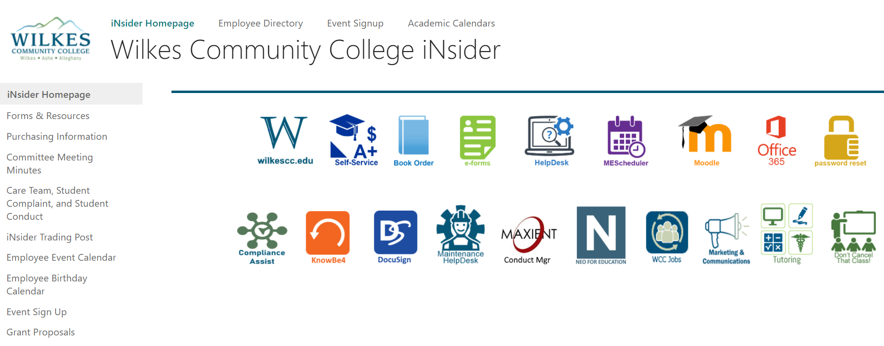
To access Compliance Assist, click on the GREEN “Compliance Assist” icon. Compliance Assist is single sign on, no additional login credentials are needed. FYI: for extra security, each user has a Federate ID, but users are not required to enter this information into Compliance Assist.
Step 2 – Click on the “Planning” link in available websites box
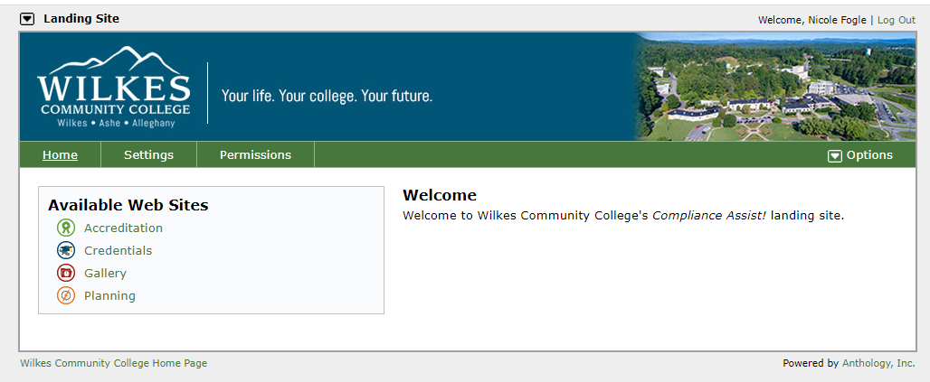

Step 3 – Click on the “My Dashboard” link
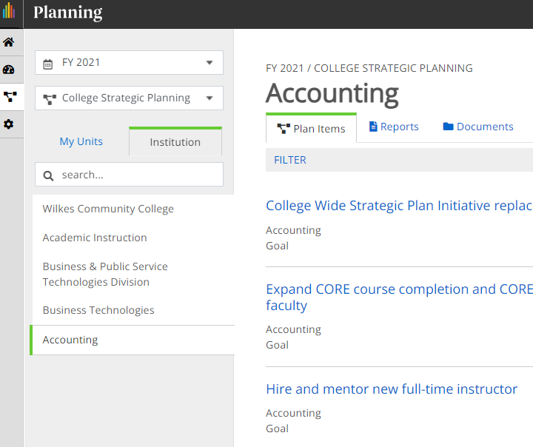

Step 4 – Click on the “College Strategic Planning” tab

Step 5 – In the organizational tree on the left‐hand side of the screen find your department and click on it

Step 6 – Mouse over “Plan Items” and then click on “Goal”

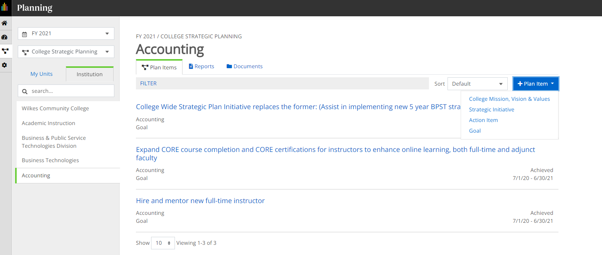

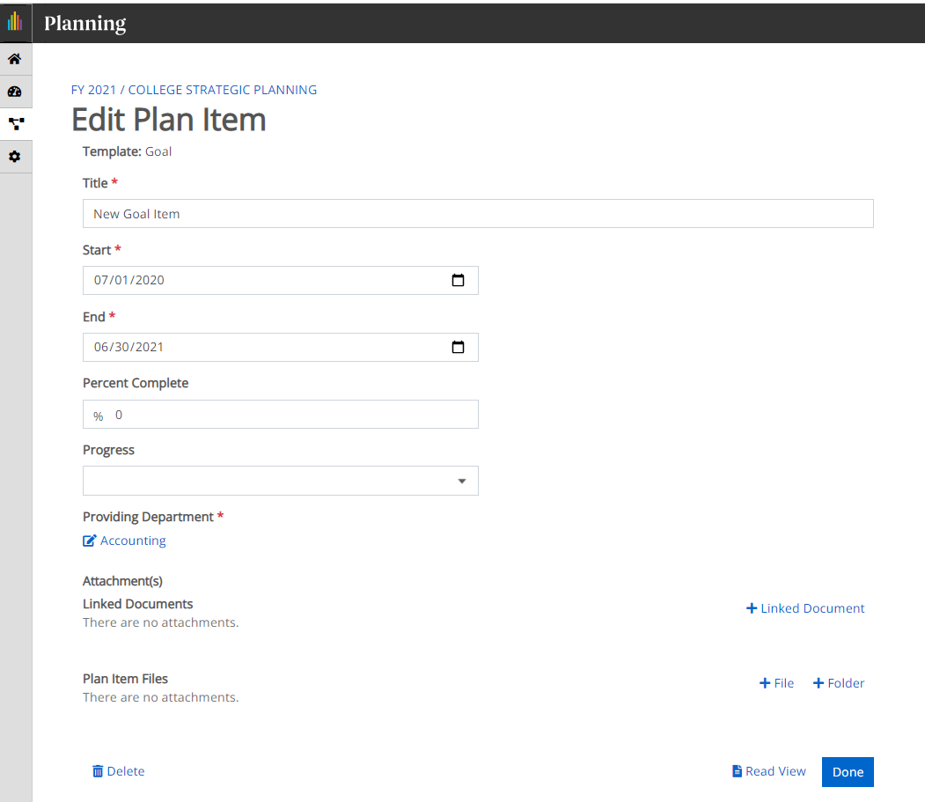

Step 7 – In the box next to “Title” type a sentence than describes your goal (examples can be found above)

Step 8 – Click “Choose Fiscal Year Dates”

Step 9 – Click on the fiscal year or years in which you will be working on this goal for example the 2019
20 fiscal year is “FY 2020” Step 10 – Click “Select” Step 11 – Click “Save”
Step 12 – Next to “Progress Complete” select the appropriate percentage of completing for this goal, if any.

Step 13 – Next to “Progress” select the appropriate description for the progress to date on this goal. Most goals should be either on schedule or achieved.

Step 14 – Under “Providing Department” your department should be selected by default, but if not select the icon to the right of the box and select the appropriate department.

Step 15 – If you have any documentation you want to attach to include with this item, under attachments click “Upload File”, next to name type in the name of the file you uploading and then click select to navigate to the file. Once the file is selected, click “Upload File.”

Step 16 – Click “Save”

Step 17 – Click on the “Related” tab near the top of the page
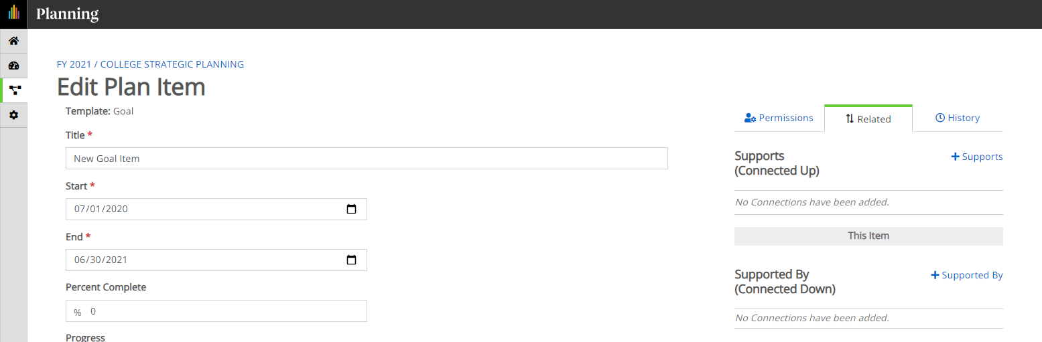
Step 18 – Under “Related” Click on “Supports (Connected Up)
Step 19 – In the organizational tree on the left of the screen click “Wilkes Community College”

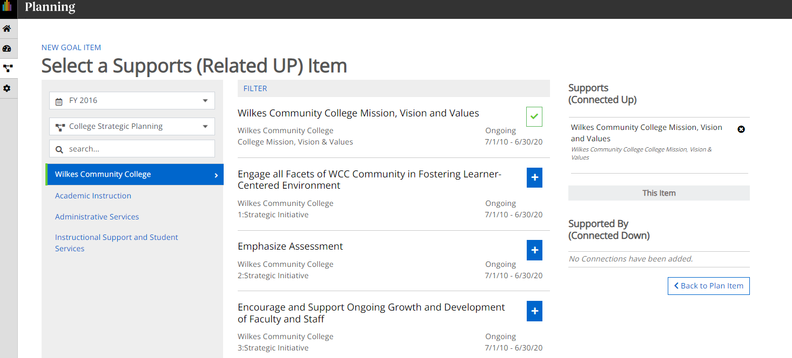

Step 20 – In the main part of the screen find which of the strategic initiatives of the college that your goal most directly supports and then click the box to the left of the initiative.

Step 21 – Click “Add”

Step 22 – Click on the “Edit” tab
Step 23 – Click on “Save and Close”
Step 24 – Return to Step 6 and repeat until all goals have been added.

Remember if you have any problems at all with Compliance Assist call or email Nicole Fogle at nefogle753@wilkescc.edu or 336‐838‐6270 at any time

